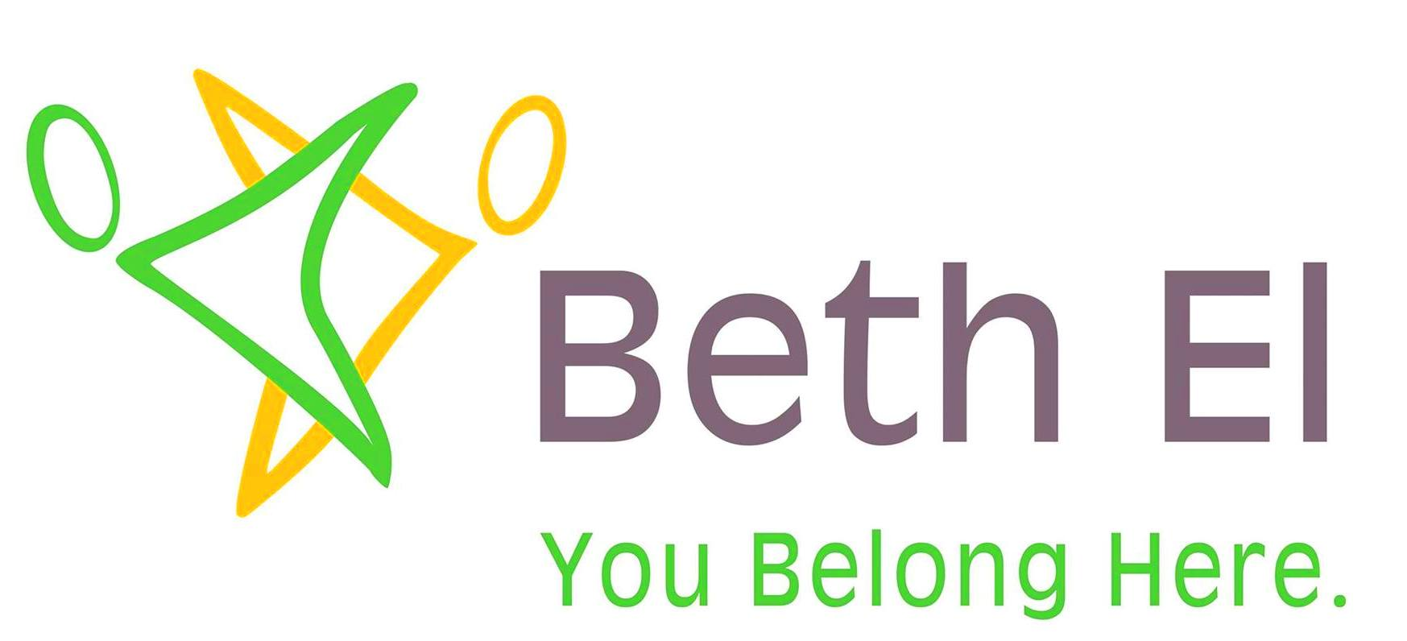 |  | 411 Hoosick Street  Troy, NY 12180  (518) 272-6113  admin@betheloftroy.org  www.betheloftroy.org
Membership Application
General Applicant Information
Name(s) of Applicant(s):
Current Address:
City: | State: |  | Zip Code:
Phone: | Cell: |  | Email:
Mailing Address (if different from above):
City: | State: |  | Zip Code:
Present and/or previous Synagogue Affiliations:
Introduced by:
Do you have any Children: Y/N. If yes, how many: ___ 0-18 ___ Over 18
Relatives at Beth El:

Member 1
Name: Last | First |  | Middle Title
Marital Status: ◻ Single ◻ Household/Married ◻ Divorced ◻ Widowed ◻ Separated
Cell phone: |  | Email:
Occupation/Profession: |  | Company Name:
Date of Birth (mm/dd/yyyy): |  | Wedding Anniversary (mm/dd/yyyy):
Hebrew Name: |  | ◻ Cohen ◻ Levi ◻ Yisrael ◻ Don’t know
Father’s Name: |  | Hebrew:
Mother’s Name: |  | Hebrew:
If not born Jewish, have you formally converted? |  | ◻ Yes ◻ No
What Hebrew knowledge or Synagogue Skills? |  | Please describe:
Chant ◻ Torah ◻ Haftorah ◻ Sing/instrument |  | ◻ Leading services ◻ Interested in learning more ◻ Other: ____________________________
Member 2
Name: Last | First |  | Middle Title
Marital Status: ◻ Single ◻ Household/Married ◻ Divorced ◻ Widowed ◻ Separated
Jewish: ◻ Yes ◻ No * We welcome non-Jewish partners and encourage them to participate in the life of our community. If you have questions, please feel free to contact Rabbi Kasman at (518) 424-2866.
Cell phone: |  | Email:
Occupation/Profession: |  | Company Name:
Date of Birth (mm/dd/yyyy): |  | Wedding Anniversary (mm/dd/yyyy):
Hebrew Name: |  | ◻ Cohen ◻ Levi ◻ Yisrael ◻ Don’t know
Father’s Name: |  | Hebrew:
Mother’s Name: |  | Hebrew:
If not born Jewish, have you formally converted? |  | ◻ Yes ◻ No
What Hebrew knowledge or Synagogue Skills? |  | Please describe:
Chant ◻ Torah ◻ Haftorah ◻ Sing/instrument |  | ◻ Leading services ◻ Interested in learning more ◻ Other: ____________________________
Last Name, First:
Membership Application

Parent Yahrzeits

Member 1:  Date of Yahrzeit (mm/dd/yyyy): | Mother’s English Name: | Hebrew Name: | Before/After Sundown:
Member 1:  Date of Yahrzeit: | Father’s English Name: | Hebrew Name: | Before/After Sundown:
Member 2:  Date of Yahrzeit: | Mother’s English Name: | Hebrew Name: | Before/After Sundown:
Member 2:  Date of Yahrzeit: | Father’s English Name: | Hebrew Name: | Before/After Sundown:
Other Yahrzeits
Date of Yahrzeit: Before/After Sundown: | English Name: | Hebrew Name: | Relationship:
Date of Yahrzeit: Before/After Sundown: | English Name: | Hebrew Name: | Relationship:
Date of Yahrzeit: Before/After Sundown: | English Name: | Hebrew Name: | Relationship:
Date of Yahrzeit: Before/After Sundown: | English Name: | Hebrew Name: | Relationship:

For Each Child (including adult children)
Name (Last, First Middle):
Hebrew Name:
DOB (mm/dd/yyyy):
Nickname:
Bar/Bat Mitzvah Date (if applicable):
Gender:
Live with Parents: | ◻ Yes ◻ No | ◻ Yes ◻ No | ◻ Yes ◻ No | ◻ Yes ◻ No
Marital Status:
Date of Marriage:
Chant Torah/Haftorah: | ◻ Yes ◻ No | ◻ Yes ◻ No | ◻ Yes ◻ No | ◻ Yes ◻ No

Last Name, First:
Please Tell Me More About:
◻ Jew Chew Reviews | ◻ Cooking Kosher – how I can participate in Jew Chew Review | ◻ Participating in /Sponsoring a Luncheon | ◻ Preparing or  ◻ Sponsoring Kiddush | ◻ Summer Ukulele Shabbat (do you play?)
◻ Bar/Bat Mitzvah preparation | ◻ Family Programming | ◻ Young Couples | ◻ Ritual (chanting Haftorah, leading services, planning) | ◻Communications/ Announcements
◻ Hebrew Study Ages: __________ | ◻ Book/Study Groups | ◻ High Holiday planning | ◻ Fundraising | ◻ Website/tech  ◻ Building/grounds
◻ Special Events | ◻ Dinner Groups | ◻ Hosting a Seder | ◻ Member outreach | ◻ Volunteering
◻ Other:

Last Name, First:
Membership Application

Our doors are always open to everyone, whether they pay or not.

Your application means you want to help us financially maintain our synagogue. Together, we decided on $750 per individual or family membership, with $33 annual fees to cover United Synagogue membership. To maintain this low fee, we cut costs, keep only part time staff and rabbi, and run a deficit. But we know that $750 does not cover all of our real costs, and seek grants and solicit donations.

Some of us pay more than the dues to help lower the deficit. A monthly increase of $18 a month reduces the deficit by $196 a year. An additional $36 dollars monthly reduces the deficit $432 a year. If you can pay anything above $783 per year, please do so.

Many of us like our dues to cover the synagogue costs without deficit. We have a “Cover Your Plate” Program that helps us cover our real expenses. We roughly divide anticipated annual costs by projected number of synagogue members. If everyone were to pay $1,358 (an additional $50 per month or $600 per year), we would be able to pay all of our bills without deficit or fundraising.

For students who want to formally support our budget, we have special student rates.

Also know that if you cannot afford $783, we are still committed to you as our member at the rate you can support us.

Signatures:
Please enroll me/us as a member of Congregation Beth El. I/We agree to pay _________ Membership dues each year.
Signature:  Date: | Signature:  Date:
I wish to be billed on an ◻ annual ◻ quarterly (Jul/Oct/Jan/Apr) ◻ monthly basis.

Sliding Scale Examples:
Dues fees (family/individual) | $750
100% funded | $1350
150% funded (help pay for someone who cannot) | $2000
Student Rate (often helping with services) | $50

